**Hypothesis Testing**

Q1.A F&B manager wants to determine whether there is any significant difference in the diameter of the cutlet between two units. A randomly selected sample of cutlets was collected from both units and measured.Analyze the data and draw inferences at 5% significance level. Please state the assumptions and tests that you carried out to check the validity of the assumptions.

Minitab File : Cutlets.mtw

Q2.A hospital wants to determine whether there is any difference in the average Turnaround Time (TAT) of reports of the laboratories on their preferred list.They collected a random sample and recorded TAT for reports of 4 laboratories.TAT is defined as a sample collected to report dispatch.Analyze the data and determine whether there is any difference in average TAT among the different laboratories at 5% significance level.

Minitab File: LabTAT.mtw

Q3.Sales of products in four different regions are tabulated for males and females. Find if male-female buyer ratios are similar across regions.

|  | East | West | North | South |
| --- | --- | --- | --- | --- |
| Males | 50 | 142 | 131 | 70 |
| Females | 550 | 351 | 480 | 350 |

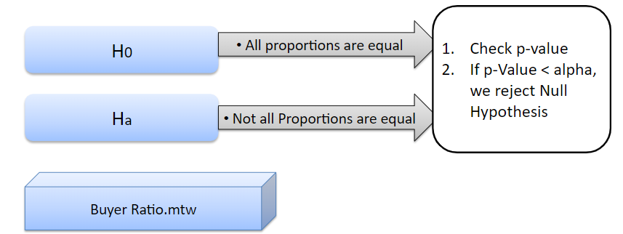

Q4. Tele-Call uses 4 centers around the globe to process customer order forms. They audit a certain % of the customer order forms. Any error in order form renders it defective and has to be reworked before processing. The manager wants to check whether the defective % varies by center. Please analyze the data at *5%* significance level and help the manager draw appropriate inferences.

Minitab File: CustomerOrderForm.mtw